**General anesthesia** is essential for surgical procedures, yet its precise mechanisms remain elusive. I designed and analyzed a new **mathematical** framework and **implemented** bio-inspired **optimization** techniquesto understand how anesthetic actions at the molecular level (receptor occupation, synaptic and extra-synaptic inhibition) translate into measurable EEG signatures of loss and recovery of consciousness.

Our **hypothesis** was that consciousness transitions involve a phase transition in neural dynamics, characterized by a sharp drop in population firing rate, visible in EEG recordings. Testing this required mechanistic modeling and efficient parameter estimation that bridges molecular-to-systems levels while remaining computationally tractable.

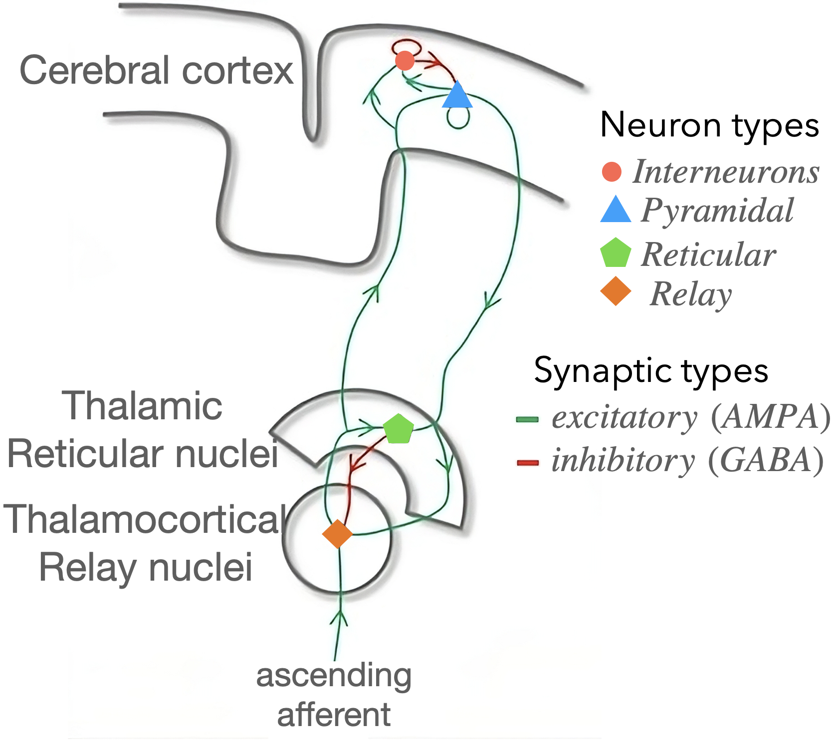

To fit a *thalamo-cortical* system to EEG data we require:  
(1) **theoretical** mechanistic modeling of neural systems from first principles, (2) mathematical analysis and inference using closed-form solutions and, (3) integrating biological constraints into inverse problems—all of which became foundational for inference at larger scales.

* + - 1. Derivation of biologically plausible thalamo-cortical system

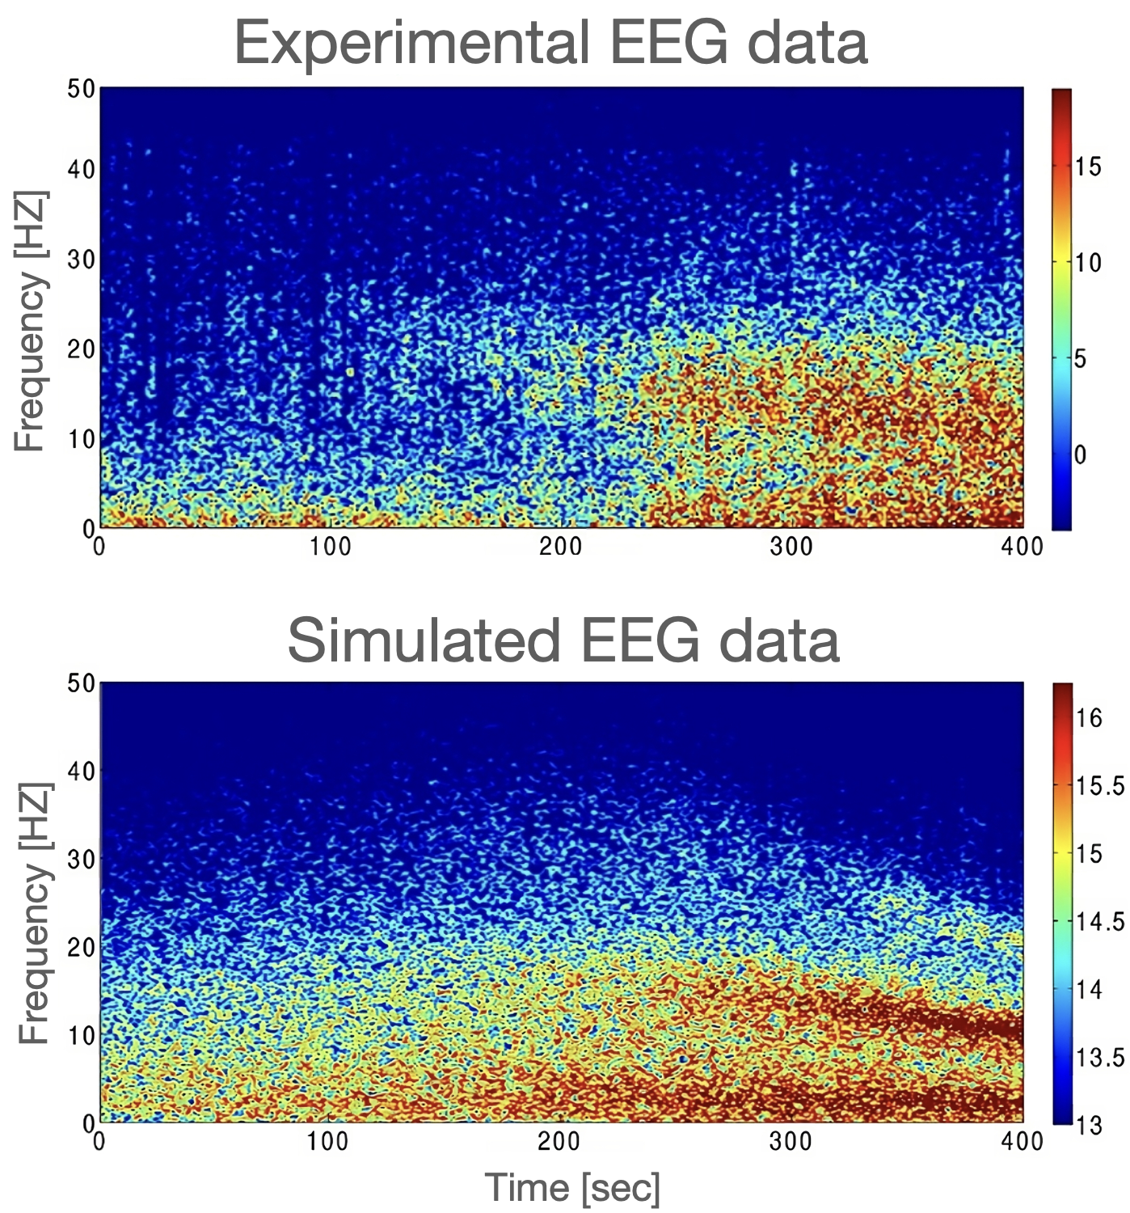

We formulated a novel **mean-field model** capable of distinguishing response functions at excitatory (*glutamatergic*) and inhibitory (*GABAergic*) synapses, while also integrating extra-synapticreceptors located in cortical and thalamic neural populations. Additionally, we mathematicallyderivedan **analytical formulation** for the firing rate of an ensemble of *type-I* neurons, characterized by an asymmetric sigmoidal function. We analytically calculated the higher-orderstability conditions, accounting for *time-delay* transmission along axonal fibers, and derived a **closed-form** **solution** for the spectral power density of EEG recordings. Notably, the analytical solutions consistently aligned with thenumerical results, demonstrating how anesthetics destabilize neural dynamics as a marker of anesthetic depth.

* + - 1. Optimal fitting of the thalamo-cortical model to EEG data

Then, the derived mean-field model was **fitted to empirical EEG** data recorded during general anesthesia induced by *propofol* and *desflurane*. To achieve this, we developed metaheuristic optimization algorithms that satisfy analytical conditions tofacilitate convergence, and adhere to **biological constraints**. These analytical constraints significantlyreduced the computationalcostof fitting the empiricalEEG data. We demonstrated that the neural population model effectively and accurately captures the characteristics features observed experimentally during anesthesia. These features include the *anteriorization* of α (8-12 Hz) and δ (1-4 Hz) rhythms, and the *beta buzz*—a shift of power from β (13-20 Hz) to α band—indicating region-specific dynamics in frontal and occipital corticalregions. **Remarkably**, **tonic inhibition** was crucial for capturing these data features.

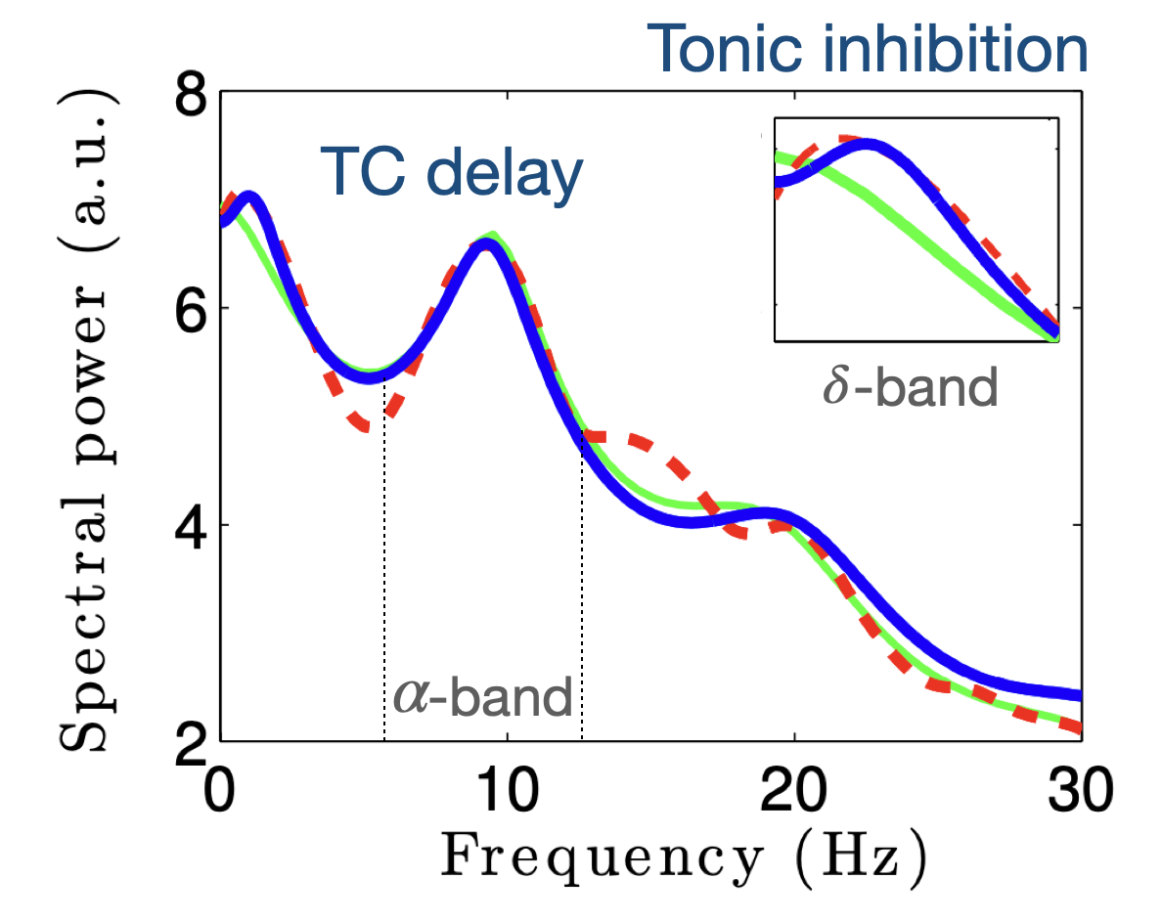

Empirical EEG during anesthesia (red),

Fitted EEG excluding tonic inhibition (green),

Fitted EEG including tonic inhibition (blue).

­

A key finding of this work is that the δ and α rhythms arise from fundamentally different mechanism. Changes in the **δ-rhythm** primarily result from alterations in (**extra-)synaptic** GABAergic inhibition, whereas the emergence of the **α-rhythm** is heavily dependent on the time-delay in the **feedback loops** between the thalamus and cortex.

**Virtual brain modelling** has gained popularity in neuroscience due to its potential to enhance medical treatmentsand **intervention strategies**. This transformative approach combines **patient-specific** **structural data** with mathematical models to simulate **spatiotemporal** brain activity and its associated imaging recordings, such as magneto/electroencephalography (MEG/EEG), stereo EEG (SEEG), and fMRI. However, **model inversion** (finding the parameter set that best explains the data)at such large-scale presents formidable challenges due to non-trivial network effects, noise, and non-linearity. Previous studies relied on optimization algorithms(i.e., *point estimation*) that are limited to integrate the background knowledge (e.g., clinical expertise). Furthermore, statistical and geometrical dependencies, such as ***degeneracy***, add another layer of complexity in revealing **causality** with associated **uncertainty**. This is crucial for **validation**, to ensure that model predictions are trustworthy.

My main methodological contribution involves **multimodal and multiscale inference methods**. These tools represent the state-of-the-art **probabilistic ML** and **generative AI** that model uncertainty and make predictions over all possible outcomes rather than only a single value. Notably, probabilistic ML, once validated using mechanistic models, can be used in scenarios where experiments are prohibitive. In contrast, generative AI is typically trained on large datasets and is designed to operate across multiple spatial and temporal scales rather than making predictions about a specific dataset.

Technically, I have developed 1) *Adaptive* Markov chain Monte Carloalgorithmsand, 2) *Amortized* simulation-based inferenceto address challenges in Bayesian inference across brain modalities and scales ([BVEP](https://wiki.ebrains.eu/bin/view/Collabs/bayesian-virtual-epileptic-patient), [Inf-MFM](https://wiki.ebrains.eu/bin/view/Collabs/inference-mfm), [DCM-PPLs](https://wiki.ebrains.eu/bin/view/Collabs/automatic-dcm/), [SBI-VBMs](https://wiki.ebrains.eu/bin/view/Collabs/sbi-vbms), [VBI](https://wiki.ebrains.eu/bin/view/Collabs/virtual-brain-inference-vbi)) featured via EBRAINS.

-- **Probability distribution**: The statistical description of potential outcomes of random events (such as synaptic transmission), where a numerical measure is assigned to the possibility of each outcome.

-- **Adaptive Markov chain Monte Carlo (MCMC**)is a class of stochastic algorithms used to draw samples from probability distributions without requiring full knowledge about the distribution. This approach is exact, and its *adaptive* strategy automatically tunes the algorithm’s hyperparameters (e.g., in [Stan](https://mc-stan.org/), [PyMC](https://www.pymc.io/welcome.html), [Pyro](https://pyro.ai/)).

-- **Amortized** **Simulation-based inference (SBI*)*** is a probabilistic inference that uses a class of deep learning so-called normalizing-flows to make efficient inferences about complex systems. *Amortization*strategy refers to the idea of reusing learned computations for fast inference on new data without re-training.

-- **Variational** andLaplace inference are approximation methods that replace complex posterior distributions with simpler forms and recast sampling as an optimization problem, e.g., used in DCM.

-- **Neural ODEs** are generative models that generate new samples resembling the original dataset

Forward modelling (bottom-up) estimates effects given the causes, while inverse modelling (top-down) estimates causes given the effects. **Bayesian inference** is a principled method for model inversion, updating background knowledge (prior) with evidence provided by the data (likelihood) to derive the posterior distribution of events. The posterior contains all information for prediction and validation. In **clinical trials** using a frequentist approach, clinical knowledge can only be used in the design phase. In contrast, the Bayesian approach **integrates** **prior knowledge** derived from patient history, past trials or imaging intopredictionsacross the *design, conduct,* and *analysis* stages. Bayesian causalestimation enables the modelling of dynamical changes in past and future events, especially wherethe **experiments are prohibitive**.

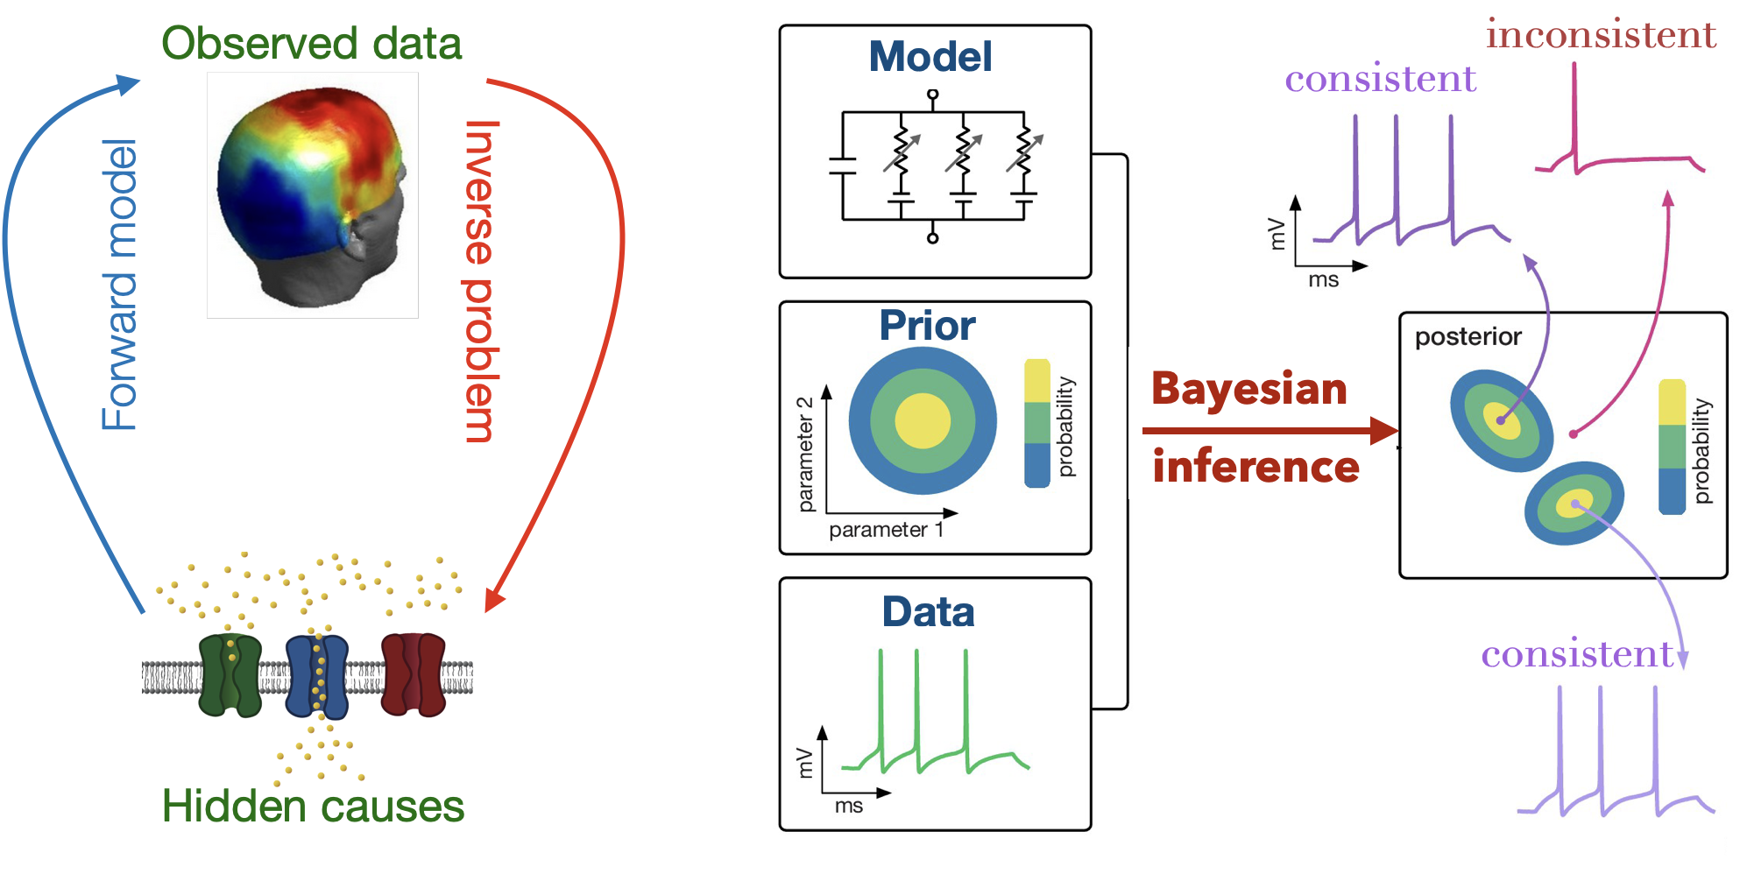

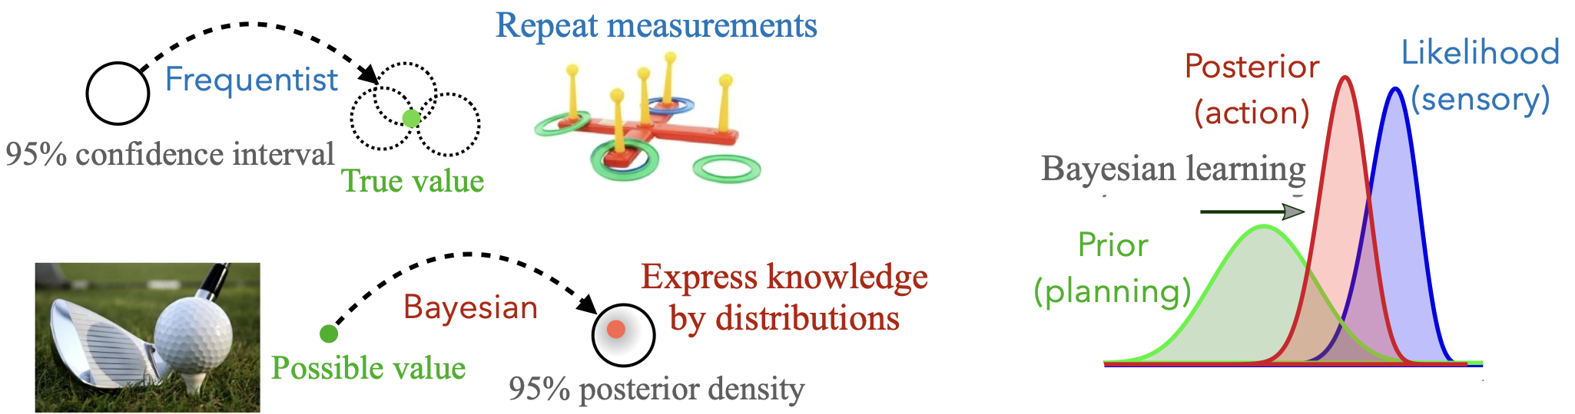

Methods for inference, such as **Markov Chain Monte Carlo** (MCMC) use stochastic algorithms based on *accepting/rejecting* samples (e.g., in [Stan](https://mc-stan.org/)), to analyze all possible outcomes and quantify uncertainty for **validation** and **decision-making**. Although MCMC is *unbiased and exact*, it is computationally expensive. Of the alternatives, **simulation-based inference** offers *flexible and efficient* Bayesian inference for complex models when MCMC is not feasible. **Normalizing-Flows**, a novel class of deep learning algorithms, are used to *transform* a simple distribution into *any complex target distribution*. Hence, they can deal with multimodalities and degeneracies across various spatiotemporal scales. **Variational and Laplace methods in high-level ML tools (e.g., in** [PyMC](https://www.pymc.io/welcome.html), [Pyro](https://pyro.ai/)) **allow for the *decorrelation* of variables, while Neural ODEs** estimate the *vector fields*, thereby inferring the system dynamics.

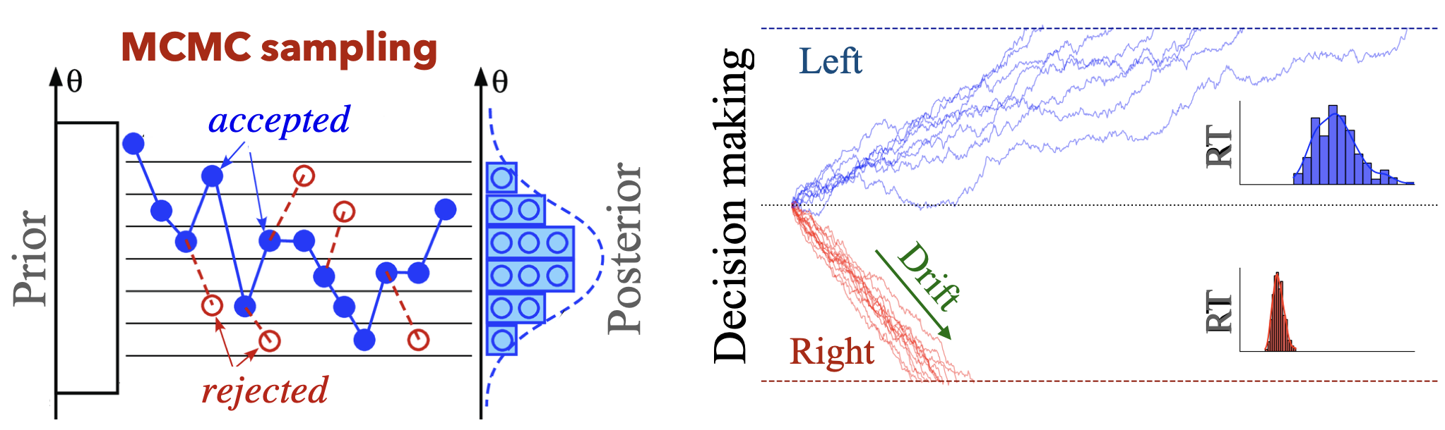

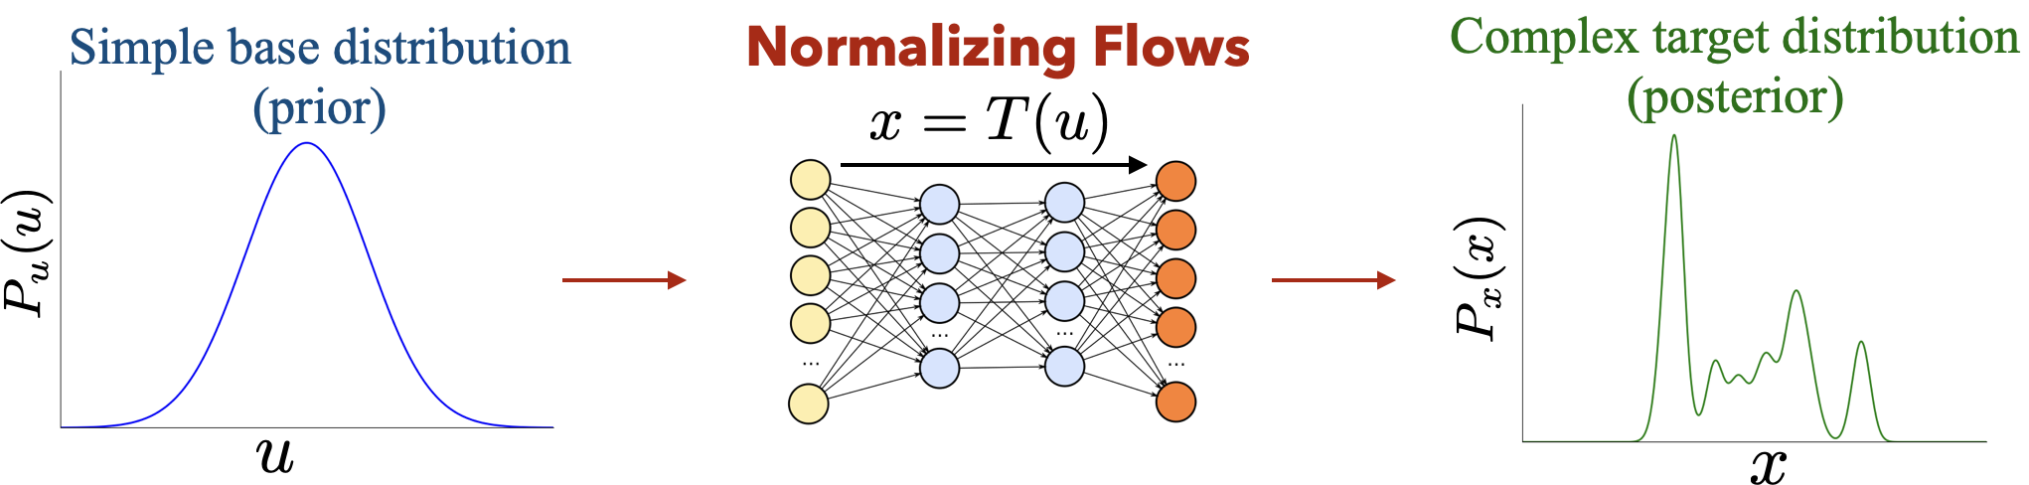

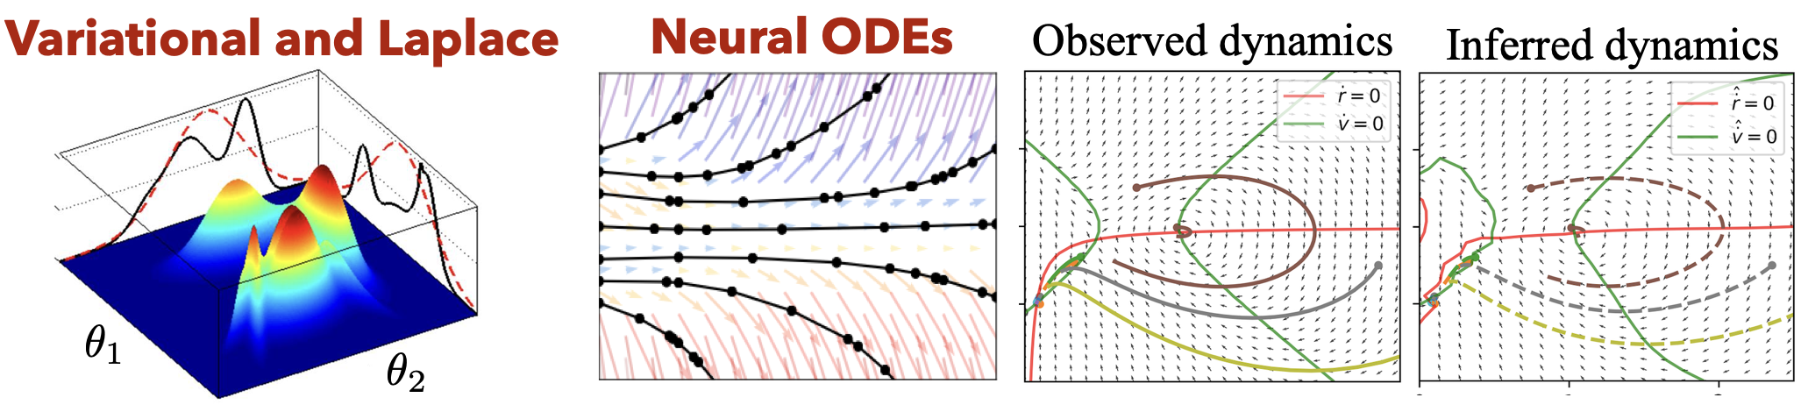

1. Bayesian Virtual Epileptic Patient (BVEP)

Epilepsy surgery is a major intervention for drug-resistant epilepsy, yet decisions are based on limited electrode coverage and visual assessment by neurologists. A patient benefit from surgery only if the resected tissue truly contains the epileptogenic zone (EZ)—the region capable of initiating seizures. However, the EZ cannot be directly observed; it must be inferred from sparse SEEG recordings, patient history, and imaging. Critically, multiple EZ hypotheses can fit the same data.

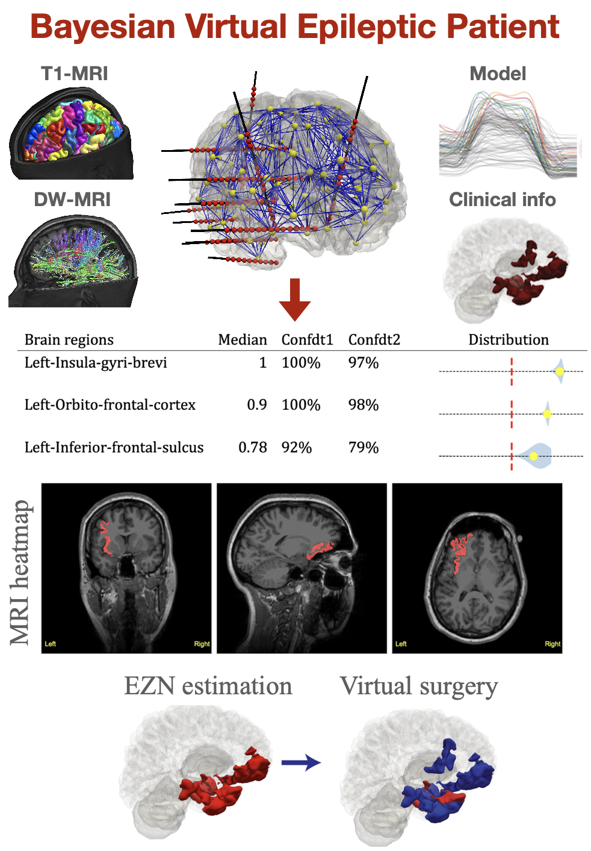

We have developed **adaptive MCMC** sampling and Bayesian optimization algorithms to systematically delineate EZ network from SEEG recordings. It demonstrated that Bayesian inference can integrate **clinical knowledge** in a principled way, a major advantage over frequentist approaches for precision medicine. In this approach, a model of seizure-like events (called *Epileptor*) is placed at each brain regions, and connected through personalized *connectome*. We introduced a novel ***reparameterization*** technique to guarantee the convergence, and established Bayesian metrics for hypothesis selection via uncertainty quantification, facilitating the virtualsurgery. We have released an **open-source pipeline** that outputs a distribution table and heatmap on T1-MRI data, which is then communicated to clinicians.The pioneer VEPand then BVEP led to many publications and patents, and is currently used in **EPINOV clinical trial**. Recently, we developed the scaling of this integrative approach to high-resolution (26,000 vertices instead of 160 regions), which significantly reduces false positives in prediction.

2. The Bayesian Pharmacometrics for Alcohol Use Disorder

**Baclofen**, as a selective *GABAB* receptor agonist, has emerged as a promising drug for the treatment of Alcohol use disorder (AUD). However, the **longitudinal** **inter-trial,** and **inter-individual variability** in drug concentration in patients with AUD is unknown. We developeda hierarchical **Bayesian workflow** to estimate the parameters of a pharmacodynamic/pharmacokinetic (PD/PK) population model from Baclofen administration. The retrospective clinical data were already collected at Sainte Marguerite Hospital in Marseille by [N. Simon](https://scholar.google.fr/citations?user=eFcbGBUAAAAJ&hl=en), and the work was co-led with [V. Jirsa](https://scholar.google.com/citations?user=0ZVdLpMAAAAJ&hl=en).

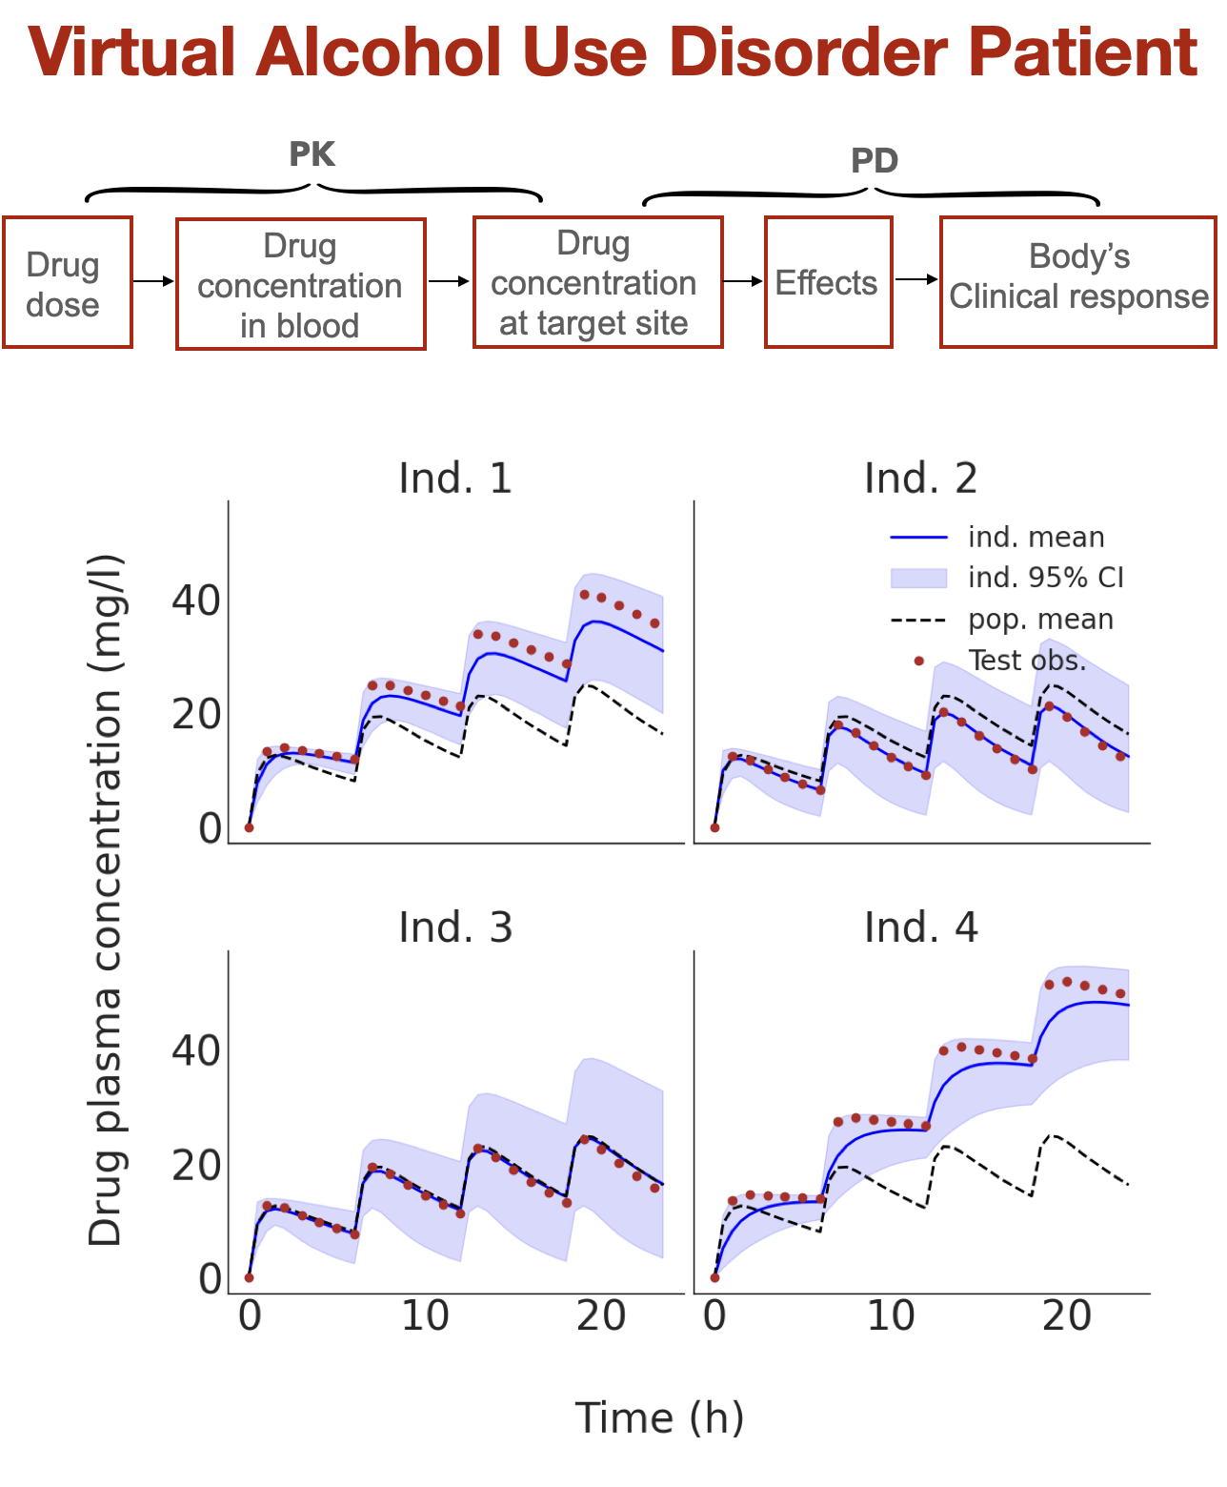

By monitoring various convergence diagnosticsfor*MCMC* sampling, the probabilistic methodology was first **validated** on **longitudinal** datasets and then applied to infer the *PD/PK* model parameters based on the clinical dataretrospectively collected from outpatients treated with oral Baclofen. We developeda hierarchical Bayesian workflow to integrate **biological and clinical information** into predictive models**.** We demonstrated this approach provides faster computation, better convergence diagnostics, and significantly higher *out-of-distribution* **prediction accuracy** (i.e., model’s adaptation to changes in properties of input data). Using this reliable approach, we are able to predict the drug concentration in the blood for any time frame and different dose regimens, **optimizing individual doses**, and potentially assisting in decision-making.

3. Virtual Brain Inference (VBI); Probabilistic inference across modalities

MCMC succeeded in epilepsy due to the invasive SEEG implantation available only to surgical candidates. To impact the broader patient population, inference must scale to **non-invasive recordings**. However, these modalities present different challenges: lower temporal resolution (fMRI: 1-2 sec), lower signal-to-noise (EEG/MEG from scalp vs. intracranial), and more computationally expensive forward models (e.g., hemodynamic equations). To address this, we developed a likelihood-free method leveraging advanced **deep generative** algorithms (called *normalizing-flows)* to learn the posterior from simulations; If we can simulate the forward model (generate synthetic SEEG/EEG/fMRI from hypothesized parameters), then we are able to train a neural density estimator to learn the inverse mapping (between data and posterior) without explicit computing the likelihood and Markovian property. Then, funded by the EBRAINS 2.0, we designed an **open-source** toolkit called [*VBI*,](https://zenodo.org/records/17144445) co-implemented with [A. Ziaee](https://scholar.google.com/citations?user=rmsueR0AAAAJ&hl=en) and co-lead with [V. Jirsa](https://scholar.google.com/citations?user=0ZVdLpMAAAAJ&hl=en), used in multiple international collaborations, demonstrating its generality and robustness.

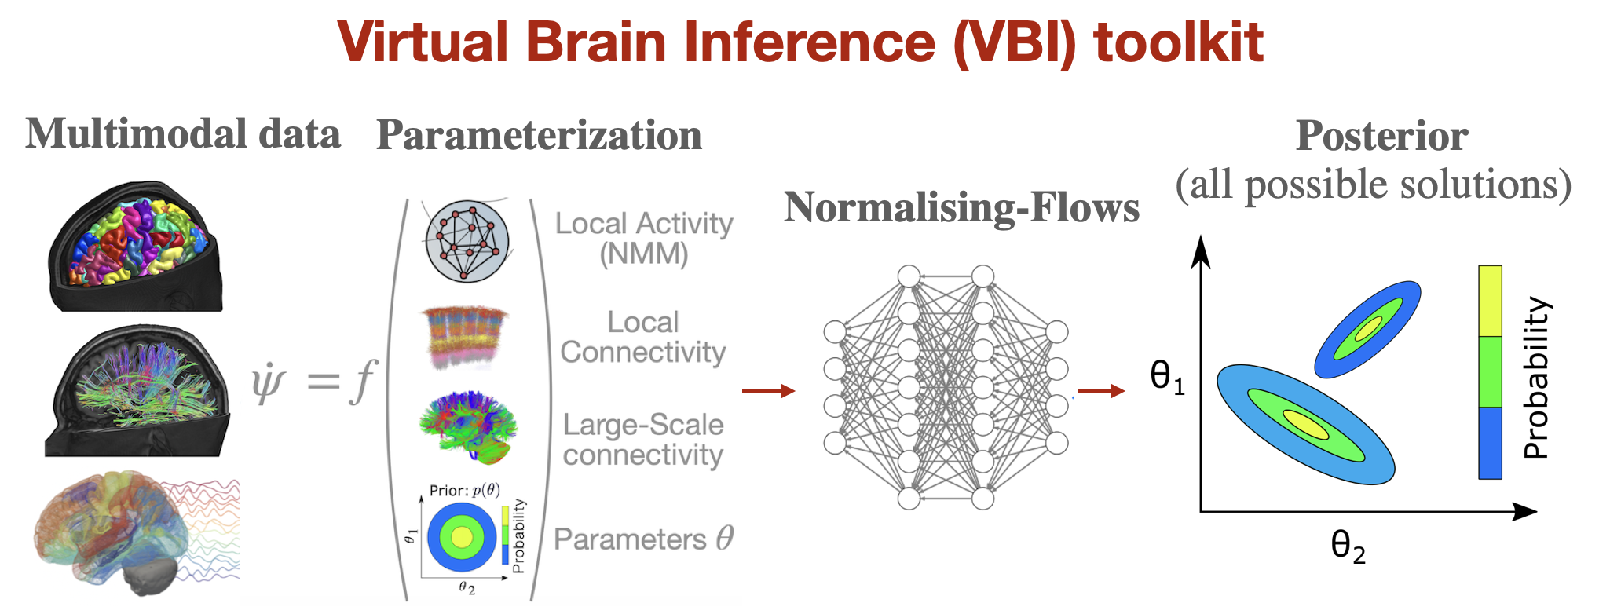

At INS, we developed the [VBI](https://github.com/ins-amu/vbi) toolkit in which, given multimodal data and subject-specific parametrization (regional dynamics, local and large-scale connectivities), trains a class of deep learning on random simulations to estimate the posterior of parameters **across** **modalities** atwhole-brain level. This tool is freely accessible via [EBRAINS](https://search.kg.ebrains.eu/?category=Software&q=vbi#83d0256f-42d4-465d-bd20-31c99276f300) and runs in the cloud.

4. Probing other’s Presence; Probabilistic inference across brain scales

An important open question is how the activity of neural subpopulations during **behavior** reflects their **causal function**. Challenges such as time-scale, granularity, along with averaging methods, obscure patterns of individual cell activity. For instance, the influence of **social presence** on behavior has been among the focal points of investigation in social psychology for over a century; however, its underlying **neural mechanisms** remain unknown. We attempted to bridge this gap by investigating how the presence of conspecifics changes *effective* *connectivity* from measurements **across brain scales** (single neurons, ERPs, and EEG). We provided a solution by investigating how the presence of others alters excitation/inhibition balance**across brain scales**—from single neurons and evoked potentials to whole-brain EEG. This study was conducted on published data by [D. Boussaoud](https://scholar.google.fr/citations?user=3mDA50oAAAAJ&hl=fr) and first author [A. Esmaeili](https://centralesupelec.hal.science/INS/hal-04785455v1).

We developed inference **across species** andscales, showing that in monkeys performing an association learning task and in humans a visuomotor task, improved behavioral performance by *conspecifics* was linked to stronger *excitatory* signalingwithin attention-orientedregions. Our multiscale probabilistic framework provides a neural basis of **social presence**, and potentially social impairments observed in clinical conditions.

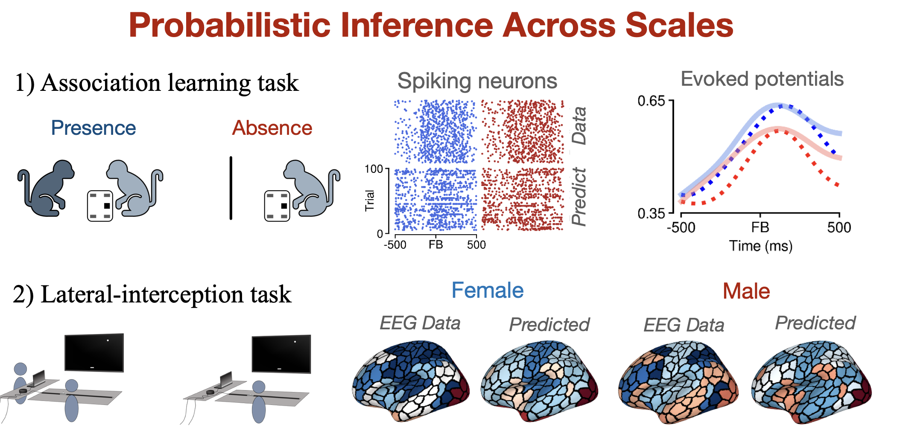

5. Virtual Multiple Sclerosis Patient

Multiple sclerosis is typically **diagnosed** based on the clinical presentation, such as structuralMRI lesions, and the “*no better explanation*” criterion. However, a conflicting scenario often arises, where a high lesion load is associated with mild **clinical impairment**, and vice versa—a phenomenon referred to as the “*clinico-radiological paradox*”. To address this, we conducted international, multicenter study to estimate averaged time-delay from MEG data recorded at the University of Naples by [P. Sorrentino](https://scholar.google.nl/citations?user=T1k8qBsAAAAJ&hl=en).

In this study we integrated personalized DTI/MEG data, with inference into personalized models of **multiple sclerosis**. We usedthe*VBI*toolkitto estimate individualized time-delays along white-matter bundles (the inverse of velocity). We demonstrated that the inferred conduction velocitiesfrompatientsaresignificantly lowerthan thoseinferredfromcontrols.Notably, the inferred delays were better predictors of **clinical disability**, outperforming demographic and clinical variables as well as lesion load. This work is **patented**. Recently, we extended this work to also infer the edge-specific conduction delay in each subject, and we plan applications to stroke in future studies.

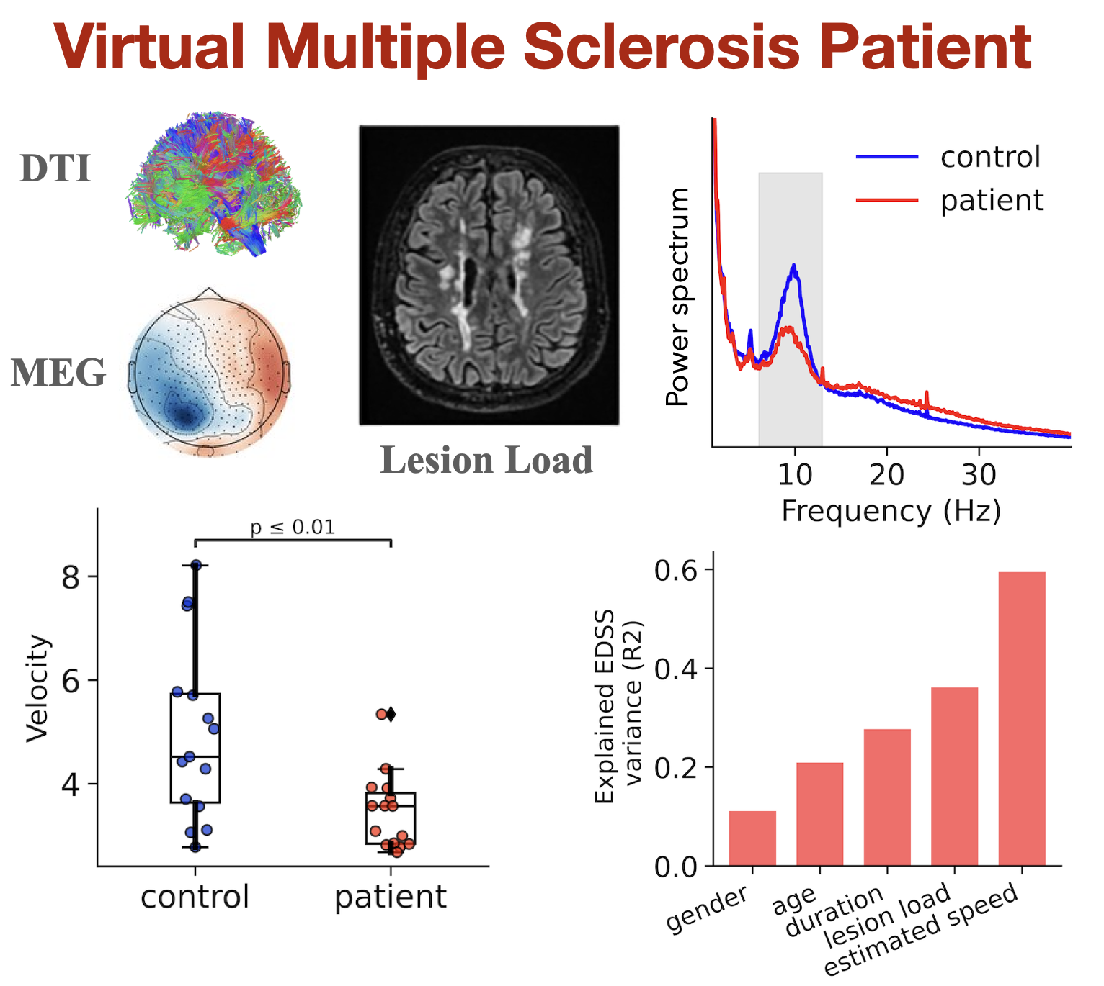

6. Virtual Brain Twins (VBTs)

**Based on the developed inference tools, several (international) collaborations were then conducted to construct mechanistic/causal frameworks for studying brain (dys)functioning;**

**In stimulation, we** showed that perturbing brain states is effective for estimating the level of degradation in the limbic system, which is **patented***.*

**In Alzheimer’s disease,** we combined structural brain topographies with excitotoxicity or postsynaptic depression to model how *Aβ* and *pTau* affect neuronal activity. Inference showed that excitotoxicity is a necessary mechanism to replicate key biomarkers, such as reduced fluidity (i.e., the switch between networks to cognitive demands), improving prediction over traditional methods.

In **Parkinson’s disease**, from EEG data and deep electrodes placed near the subthalamic nuclei, we correctly inferred dopaminergic changes before and after *L-Dopa* administration.

In **healthy aging**, causal inference showed increased *neuromodulation* as a compensation mechanism for inter-hemispheric degradation in individuals with high cognitive performance.

In **Virtual Mouse Brain**, we showed that the targeted interventions (*thalamic lesions,* and *chemogenetic* silencing) in a specific region can influence the activity throughout the entire brain.

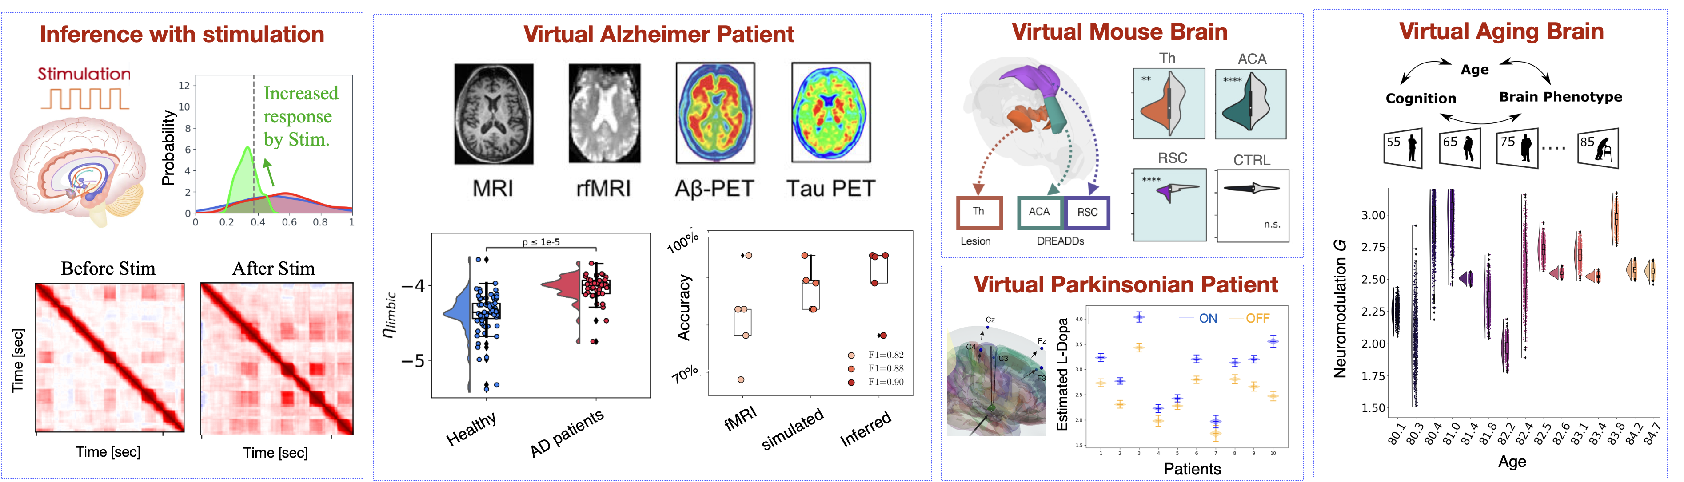

These studies led to the development of [***Virtual Brain Twins***](https://www.ebrains.eu/news-and-events/personalised-virtual-brain-twins)—digital replicas of individual brains designed to assist decision-making in diagnostics, prognosis, and therapy. Recently, we summarized these advances in a detailed review paper, covering the conceptual, mathematical, technical, and clinical aspects. We described the stages of their construction—from anatomical coupling and modeling to simulation and inference—and demonstrated case studies in resting state and **neurological disorders**.

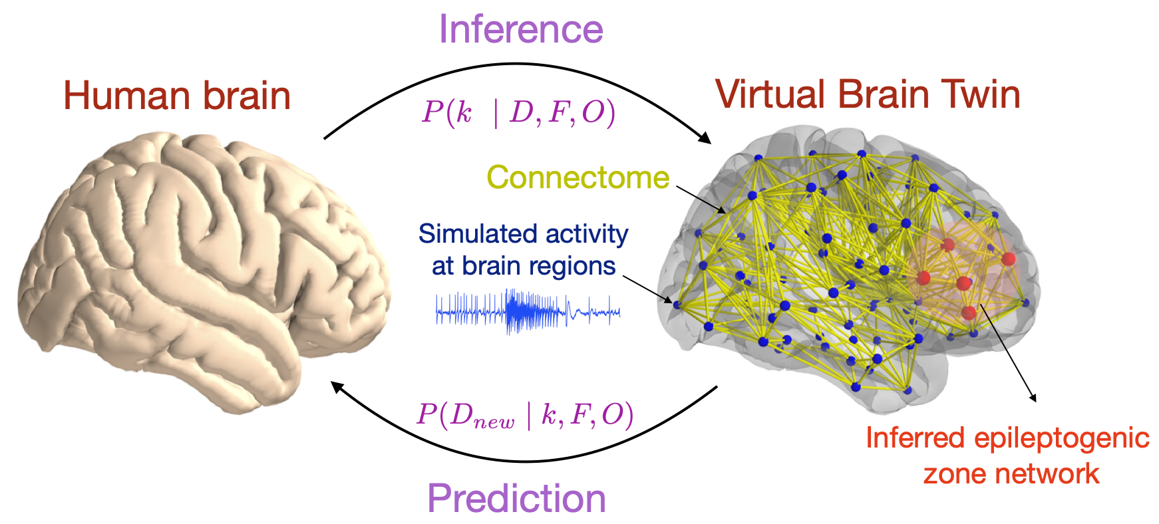

**Virtual Brain Twin** aims to create an *in-silico* *replica* of an individual’s brain, serving as a stand-alone platform for clinical hypothesis testing and **optimizing interventions** (e.g., stimulation). In contrast to model-free approaches, it is grounded in biological principles, providing access to mechanisms rather than merely estimating correlations*.* Leveraging **probabilistic deep learning***,*it enables causal inference (*epileptogenicity* or *neuromodulation*), enhances personalization,integratesclinical knowledge, andultimately **validates** **diagnostics** (e.g., by comparing the inferred network against *postoperative MRI* or acrosscohorts).

Using recorded data *D* from the human brain, given a dynamical model *F,* and a source-to-sensor mapping *O*, we can estimate the causal parameters *{k}* through Bayesian inference. This enables predictions of the treatment response probabilities, disease progression, and potential intervention. Uncertainty quantification, the predictive accuracy, and sensitivity analysis on prospective or new cohort *Dnew,* are metrics for validation.

This work integrates **Bayesian inference** with advanced computational models to enhance **clinical decision-making** for a range of brain conditions. By combining **heterogenous data** and **inference algorithms**, this approach provides **causal/mechanistic** insights into brain (dys)function, improving prediction accuracy and potentially **therapeutic strategies**.

Conclusion: